Project Tender

Project: Real-time Geospatial Data Processor and Visualiser  
Client: Werner Raath, Software Developer at AFIS, TerraNexus

Team: Ambitious Designs  
Killian Kieck, Stephen Swanepoel, Dian Veldsman, Tim Kirker  
Department of Computer Science, University of Pretoria

Date: 01 / 05 / 2016

The Team

**Killian Ferdinand Noel Kieck**

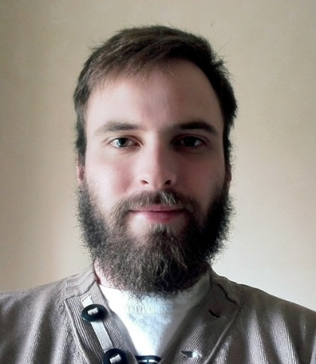

**Interests**

* Programming.
* Reading.
* Sports.
* Technology.
* Space.
* Gaming.

**Technical Skills**

* Information Technology.
* Coding / Programming (Java, C, C#, C++, JavaScript / jQuery, HTML / css, android).
* Database design and management.
* Software design and development.
* Computer networking.
* Testing.

**Past experience**

* Web design.

**Non-technical strengths**

* Quick Learner.
* Communications skills.
* Initiative.

**Why I want to do the project:**

I have a good knowledge on web-interface design and is an opportunity to improve my skills and learning to visualize the data on the site will be an interesting and rewarding experience. This project also has the potential to help people.

**Stephen Swanepoel**

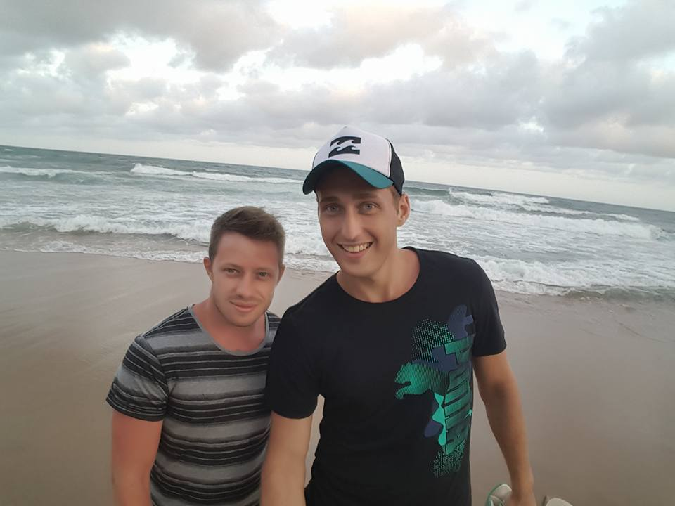

**Interests**

* Programming.
* Nature and wildlife.
* Sports.
* Technology.

**Technical Skills**

* Information Technology.
* Programming (Java, C, C#, C++, JavaScript / jQuery, HTML, CSS).
* Database design and management.
* Software design and development.
* Computer networking.
* Testing.

**Past experience**

* Web design.

**Non-technical strengths**

* Quick Learner.
* Good communications skills.
* Initiative.
* Team player.

**Why I want to do the project:**

From a developers aspect I am interested in this project as I feel it will push me out of my comfort zone and become an interesting learning outcome. This project will appeal to two large factors in my life: software development and nature so there will be no lack of interest in the project and the software desired can be incredibly helpful to some.

**Dian Veldsman**

**Interests**

**Technical Skills**

**Past experience**

**Non-technical strengths**

**Why I want to do the project:**

**Tim Kirker**

**Interests**

**Technical Skills**

**Past experience**

**Non-technical strengths**

**Why I want to do the project:**

Project Execution

**Development methodology:**

**How we intend to keep you informed about the status of your project:**

**Initial ideas for solving some of the technical challenges:**

**Technologies we plan on using:**

**What you (the client) will receive at the end of the project:**